

**Syllabus Breakdown 2019-20**

**Final Term December to March (10 weeks)**

**Mathematics syllabus (Grade 4)**

|  |
| --- |
| **December (2 weeks)**  **Ch#1 Decimals l (from 4B)** |
| **January (4 weeks)**  **Ch#2 Decimal ll (from 4B)**  **Ch#3 Time (from 4B)** |
| **February (4 weeks)**  **Ch#4 Area and Perimeter (from 4B)**  **Ch#5 Squares and Rectangles (from 4B)** |
| **March (Revision)** |

**Syllabus Breakdown 2019-20**

**Final Term December to March (10 weeks)**

**Grade 4**

|  |
| --- |
| **December (2 weeks)**   * **Folens: Snowflake** * **ORC: Two Legs or Four?** * **OPE: Food and Drink** * **Creative Writing: Rules of Application Writing** |
| **January (4 weeks)**   * **Folens: The Big Fish**   **The First Lighthouse**   * **ORC: Three Languages**   **Up-Hill**   * **OPE: Houses**   **The Four Elements**   * **Creative Writing: Sample of Application Writing and Mock Applications by Students** |
| **February (4 weeks)**   * **Folens: The Tall Giraffe**   **Bell the Cat**   * **ORC: Why the sea is salty**   **Hide and Seek**   * **OPE: Hansel and Gretel**   **Safety First**   * **Creative Writing: Dialogue Writing Rules and Samples** |
| **March (Revision)**   * **Worksheet of Folens** * **Worksheet of ORC** * **Worksheet of Creative Writing** |

**Syllabus Breakdown 2019-20**

**Final Term December to March (10 weeks)**

**Grade 3**

**s.st**

|  |
| --- |
| **December (2 weeks)**   * **Calendars** * **Festivals** |
| **January (4 weeks)**   * **Where We Live?** * **Life in a Village** * **Early People** |
| **February (4 weeks)**   * **Religion** * **Human Rights** |
| **March (Revision)**   * **Revision will be done with the help of worksheets** |

**Syllabus Breakdown 2019-20**

**Final Term December to March (10 weeks)**

**Grade 4 s.st**

|  |
| --- |
| **December (2 weeks)**   * **Power, minerals, and industries** * **Transport** |
| **January (4 weeks)**   * **Communications** * **The Government** * **The Law** |
| **February (4 weeks)**   * **Muslim rule in the subcontinent** * **Religion and Languages** |
| **March (Revision)**   * **Revision will be done with the help of worksheets** |

**Syllabus Breakdown 2019-20**

**Final Term December to March (10 weeks)**

|  |
| --- |
| **December (2 weeks)**   * **Folens: The Match Girl** * **ORC: Baba Yaga** * **OPE: Let’s visit Earth!** * **Creative Writing: Rules of Application Writing** |
| **January (4 weeks)**   * **Folens: Boeing 747**   **One Man’s Horse**   * **ORC: Dreams**   **The Thrush Girl**   * **OPE: Weddings**   **Gifted Children**   * **Creative Writing: Sample of Application Writing and Mock Applications by Students** |
| **February (4 weeks)**   * **Folens: The Polar Bear**   **Walk on the Moon**   * **ORC: The Pied Piper**   **Mr Nobody**   * **OPE: The Magic Glove**   **Life-Saving**   * **Creative Writing: Dialogue Writing Rules and Samples** |
| **March (Revision)**   * **Worksheet of Folens** * **Worksheet of ORC** * **Worksheet of Creative Writing** |

**Syllabus Breakdown 2019-20**

**Final Term December to March (10 weeks)**

|  |
| --- |
| **December (2 weeks)**  **Science grade 1: The weather**  **Science grade 2: Seasons**  **Science grade 3: Wind and air**  **Science grade 4: The earth in space**  **English grade 1: Tigers (Folens)**  **English grade 2: Who jumps the high (Folens)** |
| **January (4 weeks)**  **Science grade 1: We use electricity,movement,food energy**  **Science grade 2: Water,air,the environment**  **Science grade 3: Circuits,energy,force**  **Science grade 4: Heat,circuits and switches**  **English grade 1: Wild beast (ORC),Mr. Fox and Mr. Goat (ORC),The real princess (Folen),Sheep(Folen),Make sandwitch (activity book)**  **English grade 2: The boy who never told a lie (ORC),The kind dolphins (ORC),Kings of bird(Folen)** |
| **February (4 weeks)**  **Science grade 1: Food energy, sounds,light and shadow**  **Science grade 2: Electricity,sounds, light and shadow**  **Science grade 3: Sounds,light and shadow**  **Science grade 4: Forces and machines,light**  **English grade 1: Sheep(Folen), Doctor Dan(ORC),Clouds(ORC),Chimpanzee (Folen)**  **English grade 2: The Rocks (ORC),My New Rabbit (ORC),The Lady Bird(folen),Make Pan Cake(activity book)** |
| **March (Revision)**  **Science grade 1: revision**  **Science grade 2: revision**  **Science grade 3: revision**  **Science grade 4: revision**  **English grade 1: revision**  **English grade 2: revision** |

**Creative writing topics ( Grade 1 )**

**Grade 1**

**Paragraph writing portion**

* **Why I like school**
* **What I do in my free time**
* **My favourite hero**
* **How I celebrate my birthday**
* **My favourite restaurant**
* **My favourite picnic place**

**3 comprehensions**

**Grade 2**

**paragraph writing**

* **Should kids to school in summers**
* **Vegetable I like and why**
* **Effects of pollution**
* **Should we eat fast food**
* **How to help others**
* **Trees are our friends**
* **How travelling affects the life and personality**

**3 comprehensions**

**Dictation words: grade 1**

* **Favourite**
* **Because**
* **Party**
* **Invitation**
* **Celebration**
* **Enjoy**
* **Food**
* **Excellent**
* **Amazing**
* **Tasty**
* **Play**
* **Weekend**
* **Football**
* **Games**
* **Ground**
* **Park**
* **Cricket**
* **Badminton**
* **Like**
* **Make**
* **Scarify**
* **World**
* **Founder**
* **Making**
* **Different**
* **Learning**
* **Precious**
* **Famous**
* **Rich**

**Dictation words: grade 2**

* **Ice cream**
* **Hot**
* **Sunny**
* **Warm**
* **Cold**
* **Water**
* **Activities**
* **Healthy**
* **Vitamins**
* **Minerals**
* **Energy**
* **Life**
* **Active**
* **Fresh**
* **Smoke**
* **Environment**
* **Fresh air**
* **Plants**
* **Flowers**
* **Rubbish**
* **Burgers**
* **Pizza**
* **Cupcakes**
* **Sweets**
* **French fries**
* **Learning**
* **Confidence**
* **Journey**

**Comprehension : grade 1**

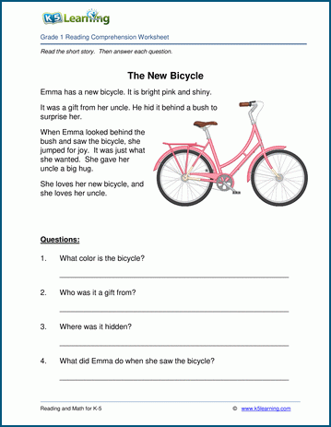

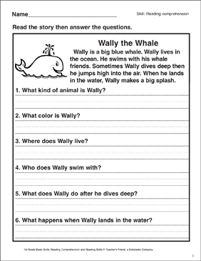

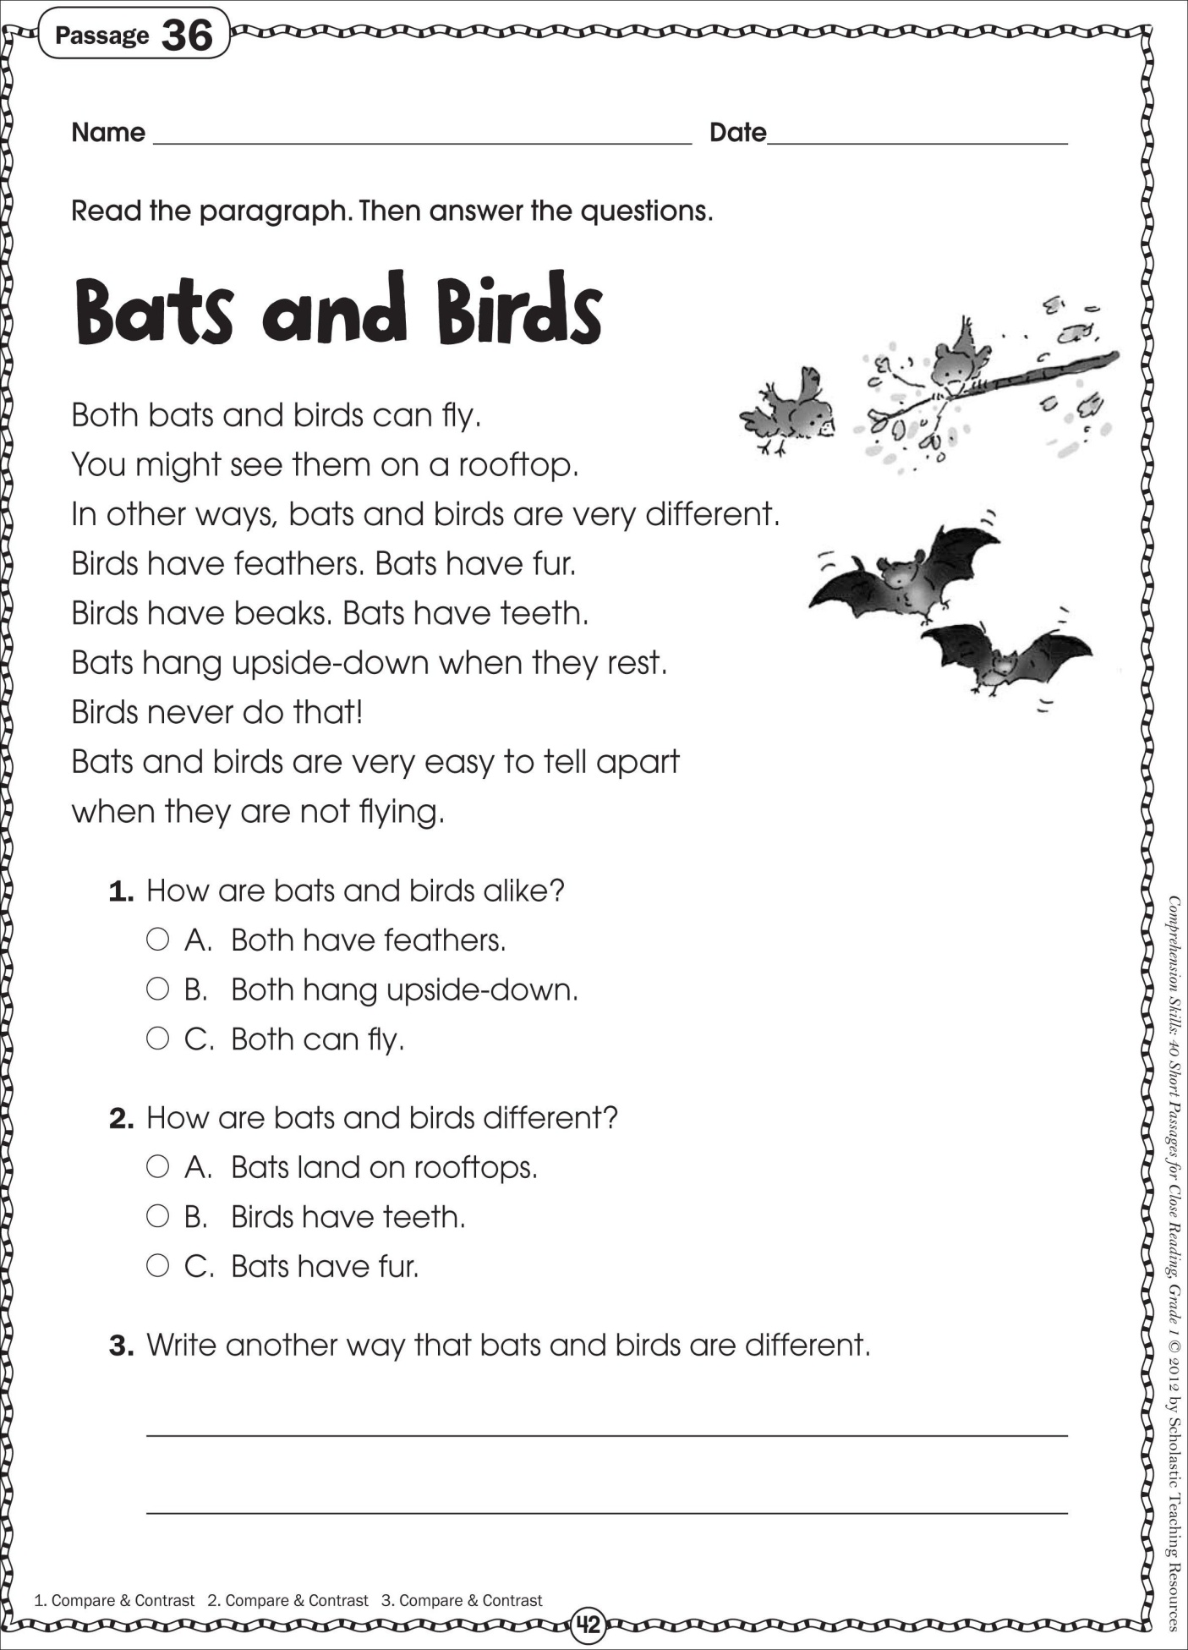

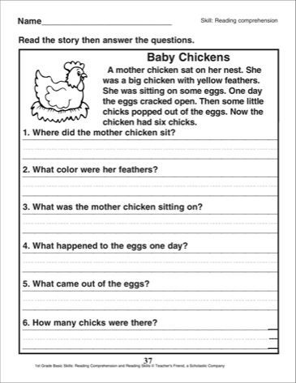

**Comprehension : grade 2**

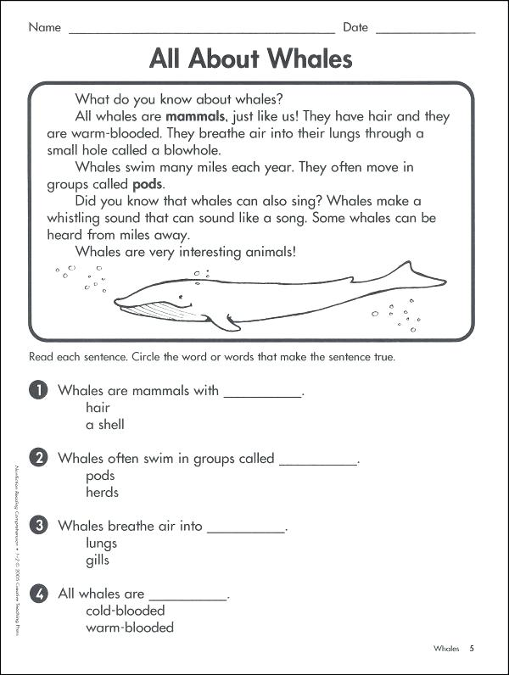

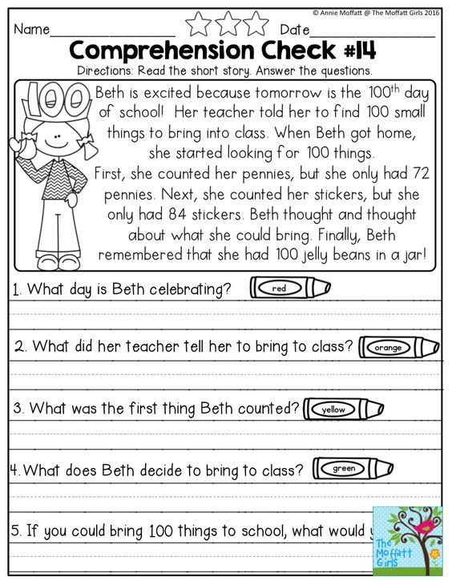

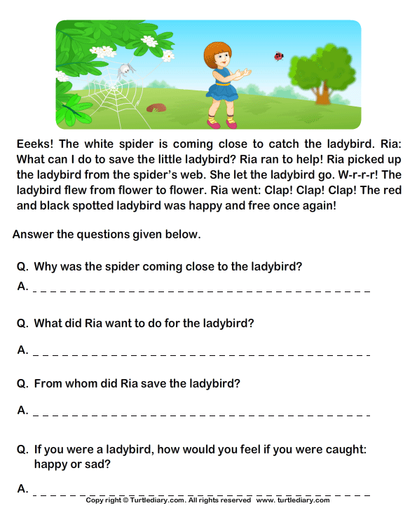

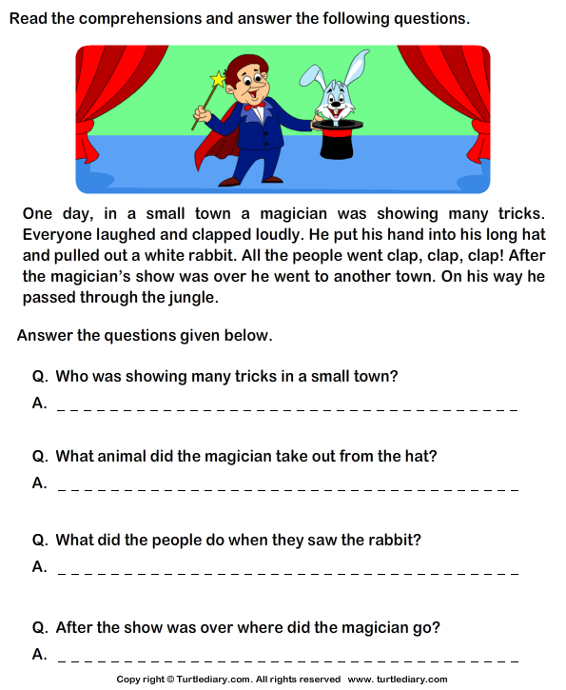

**CREATIVE WRITING TOPICS**

**GRADE 3 & 4**

**Application Writing Topics:**

* **Application for sick leave (Sample)**
* **Write an application to the Principal of your college for increasing library facilities.**
* **Write an application to the Principal of your college seeking permission to stage a drama in the school auditorium.**
* **Write an application to the Principal of your college for setting up a canteen in your college.**
* **Write an application to the Principal for changing the whiteboard of your classroom.**

**Dialogue Writing Topics:**

**Dialogue writing**

* **Between two friends discussing about their exams.**
* **Between two friends on the importance of tree plantation.**
* **Between a teacher and a student on water conservation.**
* **Between two friends discussing their favorite players.**
* **Between two friends discussing computer technology.**

**Dictation words for grade 3 and 4**

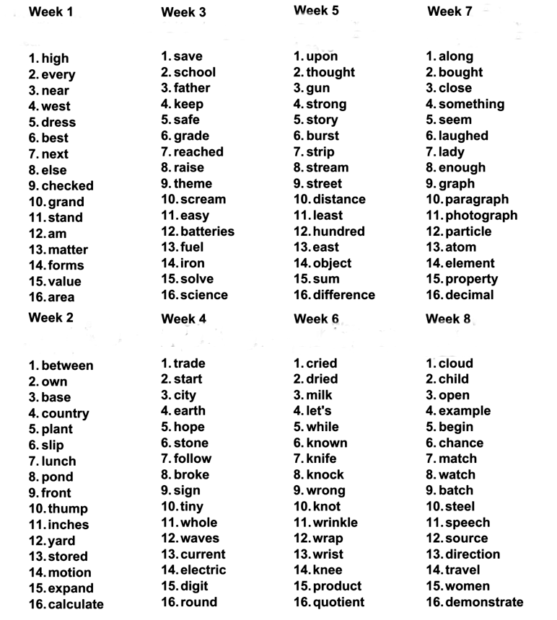

**Syllabus Breakdown 2019-20**

**Final Term December to March (10 weeks)**

**CLASS: - 3RD SUBJECT: - Computer**

|  |
| --- |
| **December (2 weeks)**  **CHAPTER 6:- Editing text in word 2013** |
| **January (4 weeks)**  **CHAPTER 7:- Formatting text in word 2013** |
| **February (4 weeks)**  **CHAPTER 8:- Enjoy with Tux paint** |
| **March (Revision)**  **CHAPTER:- 6,7,8** |

**Syllabus Breakdown 2019-20**

**Final Term December to March (10 weeks)**

**CLASS: - 4TH SUBJECT: - Computer**

|  |
| --- |
| **December (2 weeks)**  **CHAPTER 4:- More about Tux paint** |
| **January (4 weeks)**  **CHAPTER 6:- Formatting in word 2013** |
| **February (4 weeks)**  **CHAPTER 7:- Feature of Word 2013** |
| **March (Revision)**  **CHAPTER:- 4,6,7** |



**Syllabus Breakdown 2019-20**

**Final Term December to March (10 weeks)**

**Mathematics syllabus (Grade 3)**

|  |
| --- |
| **December (2 weeks)**  **Ch#1 Money (from 3A)**  **Ch#2 Fraction (from 3B)** |
| **January (4 weeks)**  **Ch#2 Fraction (from 3B)**  **Ch#3 Time (from 3B)** |
| **February (4 weeks)**  **Ch#4 Bar Graphs (from 3B)**  **Ch#5 Area and Perimeter (from 3B)** |
| **March (Revision)**  **Worksheet will be use related to the chapters.** |

**Syllabus Breakdown 2019-20**

**Final Term December to March (10 weeks)**

**Grade 2 Mathematics**

|  |
| --- |
| **December (2 weeks)**  **CHAP: Multiply by 5 and 10 (book 2b)** |
| **January (4 weeks)**  **CHAP: length (book 2b)**  **CHAP: mass (book 2b)** |
| **February (4 weeks)**  **CHAP: volume**  **CHAP: picture graph** |
| **March (Revision)**  **REVISION of chap length,mass ,volume, picture graph** |



**Syllabus Breakdown 2019-20**

**Final Term December to March (10 weeks)**

**Mathematics syllabus (Grade 1)**

|  |
| --- |
| **December (2 weeks)**  **Ch#8 (from 1A)**  **Ch#9 Numbers to 100 (from 1B)** |
| **January (4 weeks)**  **Ch#9 Numbers to 100 (from 1B)**  **Ch#10 Addition and subtraction (from 1B)** |
| **February (4 weeks)**  **Ch#13 Multiplication (from 1B)**  **Ch#14 Division (from 1B)**  **Ch#15 Fractions (from 1B)** |
| **March (Revision)**  **Worksheet will be use related to the chapters.** |